Adult Services Newsletter – February 2017 Newsletter
AFC Day- Show Support

IN THIS ISSUE
1. Adult Foster Care Day
2. Happenings at LOU South
3. SSI News
4. Residential
5. LOU North
6. PBS Recognitions
7. Marshmallow Challenge

RECYCLING at LOU South

Adult Foster Care Day
The Adult Foster/Family Care (AFC) Program was developed by Mass Health to encourage family members to be caregivers for a loved one, to keep them at home in their safe and secure environment. The AFC program at the Cardinal Cushing Center provides assistance to more than 60 families across the South Shore and Boston area
This program is facing unprecedented budget cuts that have supporters statewide planning a strong show of support at the 1st annual Adult Foster Care Awareness Day to be held on Wednesday, March 8, from 9am – 2pm in the Nurse’s Hall at the Statehouse in Boston.
Organized by the Massachusetts Council for Adult Foster Care, the gathering will offer an opportunity for families and providers to talk with their local legislators about the benefits of the program.
Cardinal Cushing Centers is proud to participate in the Adult Foster Care Awareness Day. If you would like to attend, please call Pat Conley, AFC Director, at 781-829-4608.
If you can not attend, please consider calling your local State Representatives and Senators and let them know you support reversing the cuts to AFC.
More details about Adult Foster Care Awareness Day will be posted on the Massachusetts Council for Adult Foster Care http://www.massafc.org website.

Adult Services Newsletter – February 2017 Newsletter

2. LOU SOUTH

It was a busy Fall at LOU South! Folks participated in many community outings and took advantage of the wonderful warm weather that lasted so long. Many trips were made to Cushing to walk the track and take nature walks to collect leaves and enjoy the fresh air. The annual Halloween party included a lip sync contest which was thoroughly enjoyed by all! LOU program participants also enjoyed a special trip to the South Shore Natural Science Center in Norwell in November. There they visited the wildlife and walked the trails.

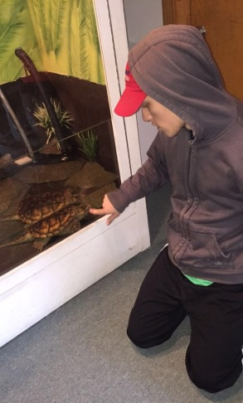 Winter also has been busy with activities both inside the program and out in the community. Doggie Day Care trips are still a big hit with some of our individuals where they play with the small dogs. The Stewart Farm re-opened after a closure due to summer bee activity, and trips to the Hanover Senior Center have also resumed. Delivering Meals on Wheels, Timber Lanes Bowling, and shopping at Shaw’s continue as well, with each group taking a turn monthly to cook and serve the Friday lunch to friends.

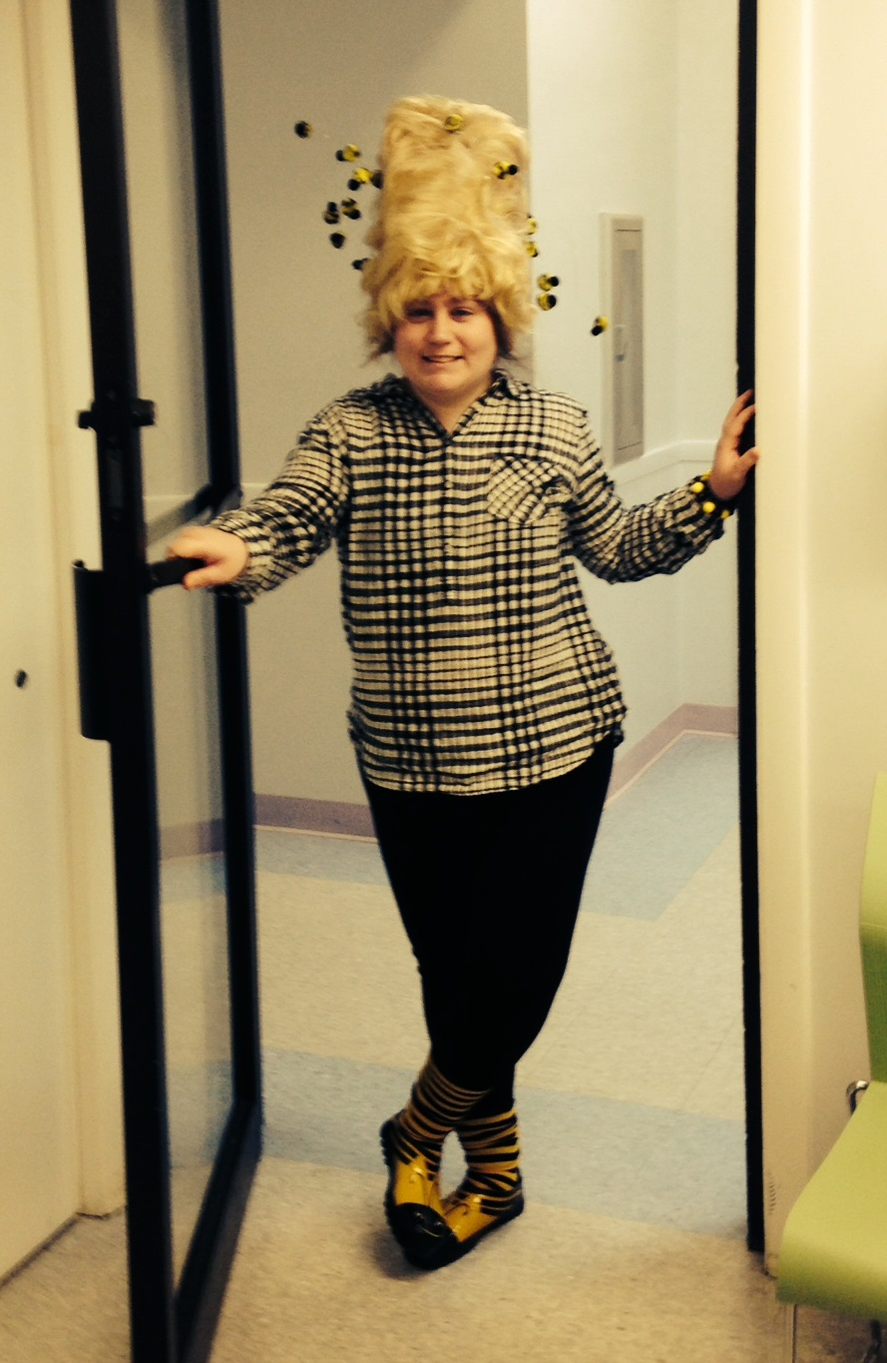 In January, we had fun on “Hat Day” and three of our individuals took home gift cards for the best hats! The winner was Emilee D! The past few weeks, of course, was very exciting when we celebrated the New England Patriots with a pre-Super Bowl party and then watched the parade and festivities in the Orange Room! Our individuals have hopefully just enjoyed a few snow days relaxing at home, but other than that, Mother Nature has been kind to us….Enjoy the remainder of Winter 2016-17!

Adult Services Newsletter – February 2017 Newsletter
3. SSI Braintree

This quarter the LOU program is featuring our new recycling program, spearheaded by Daniel S. Daniel was interested in having a specific responsibility during the day at the LOU. Upon discussion, it was determined that he would like to help us be great stewards of the environment and do a better job recycling our paper and cardboard.
We quickly added more blue recycle bins to many areas of the building. Daniel began a daily schedule whereby he collects the paper/cardboard and (with the help of George) deposits it in our large bin in the parking lot which is picked up by THORPE Co.
When there is a large amount, Daniel invites a friend to help, and also sometimes takes out trash and/or and bottles & cans to the Recycling Center on campus. Daniel is doing a fantastic job with this new program. He demonstrates much responsibility and attention to detail. Soon we plan on scheduling a time when Daniel can speak to program participants and staff to share some of his knowledge and give us needed recycling rules and reminders.

Even the cold of winter can not slow down the productivity and progress being made at SSI. We have established some new relationships in the community. We are in the initial stages of collaboration with Weymouth High School about doing Skills Assessments with our folks on some of their cafeteria positions. Marie Poulin has already applied for a job as a substitute cafeteria worker and was accepted!! Marie is waiting to start her training soon.
We have also started volunteering at the Marina Bay Nursing and Rehabilitation Center. Clara Nichols, Allison Getz, Lee Rasiel and John Gault are leading activities and doing patient visits each on their own day. Everyone is enjoying having them visit!

Employee of the Month
November- Teddy Hunter
December- Susan Mulligan

**We hope to be moving to our new space within a few weeks**

4. SSI Hanover

Adult Services Newsletter – February 2017 Newsletter

“Blizzard Season”
If you haven’t noticed, and it’d be pretty hard not to, it’s February. And just like the past few years it’s another cold and snowy one down here on the South Shore. However while schools, programs, and families were battening down the hatches and closing their doors, there was one place in town working hard to get their doors open. It’s almost even as they were welcoming the snow and maybe it because they were. It is after all the one place, even in the summer, were you’d expect, and even hope to find a Blizzard. That’s right folks; the New Dairy Queen on Rt. 53 is finally open!! And while there has been much buzz and anticipation by burger and ice cream enthusiasts about the South Shore, nobody was more excited for the Grand Opening than the four SSI- Hanover participants who were able to start their new jobs. After weeks of orientation, training, and waiting patiently, Kendra B, Suzanne M, Graham S, and Brooke T were able hit the ground running; running food that is. All four have been hired to help in the front of the house and have been doing an excellent job greeting customers, busing tables, and running food and ice cream from the kitchen to the dining room. If you haven’t stopped by yet, pop in for lunch between 11-2 to grab a blizzard and let Brooke, Graham, Kendra, or Sue say hello with big smile and a Welcome to Dairy Queen!

Adult Services Newsletter – February 2017 Newsletter
4. Staying Healthy in Adult Residential

Although the weather is cold and the snow falls, Adult Residential houses stay active and busy through the winter months. Residents continue to go to the YMCA and of course Zumba- to shake and dance away the winter blues. The men who live at Washington street stay active by walking the track, going to basketball—and they track their success with their FitBits. To stay motivated, they compete in FitBit challenges with one another and their families to see who can do the most steps. The guys were more than happy to STEP up to the challenge! Go ahead; just ask Brent Yoshida or Traves Harris how many steps they have! The men who live in our Rockand home take part in mall walking in the mornings on weekends to stay active since the track they frequent in Rockland is covered in snow.
While physical activity contributes to overall health, taking part in activities that bring joy and tap into the creative side contributes to what it means to be healthy. “Community Voices” in Duxbury continues to be a fabulous partnership where members rehearse songs for their concert at the end of the season. Singing is a passion for Kevin Lockwood, Caroline Dane, Heidi Domos, Amanda Lederman and Lee Raseil and they look forward to their concerts at the end of the season to showcase their talents. They’re supported by many friends and family who attend the concert! Lee goes one step further with his musical talents and takes lessons and practices the piano and drums. While inside on a cold day, you can find Bridget Studley crafting up a storm, something beautiful with glitter always comes from her craft table and she loves sharing her crafts with friends and family. But it MUST be mentioned that one of the favorite winter activities that has taken place this winter is watching the Patriots win the Super Bowl on February 5th! There were Super Bowl parties and snacks at every home—and I think the Patriots heard our cheers from Houston! (From our male home in Whitman especially!)
If interested in Community Voices, please contact Eve Montague at: evemontague@verizon.net

Adult Services Newsletter – February 2017 Newsletter

5. News at LOU North

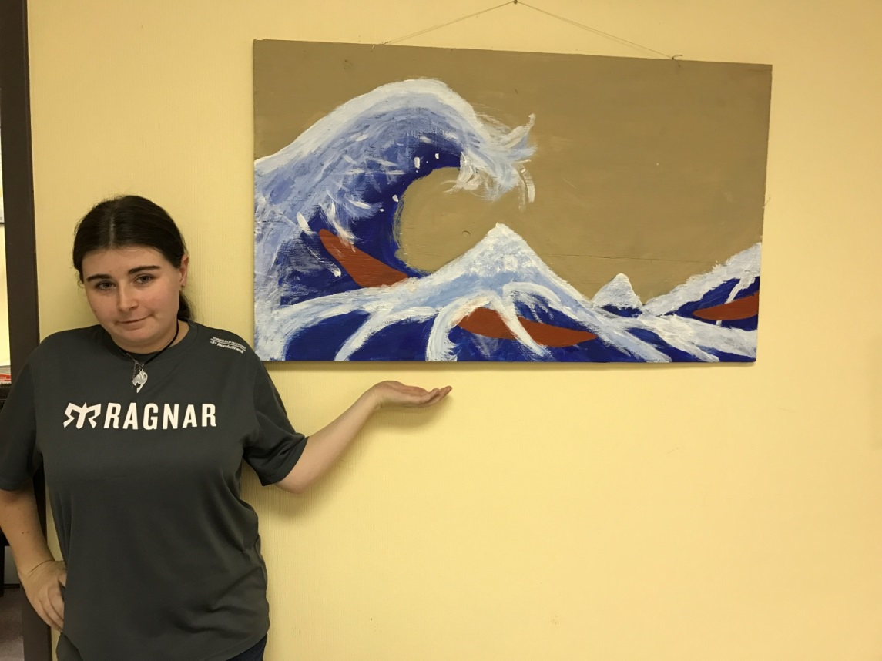

“The Great Wave” is an iconic masterpiece, a woodblock print, by Japanese artist Hokusai. The Individuals in the O2 group of LOU North put the most work into the painting however all groups did participate. First they obtained a piece of plywood found on the side of the road over the summer. Staff/Art Instructor, Catherine DeQuinzio, outlined the general shape of the wave to start. One half of the O2 group focused on filling in the sky while the other half painted the wave completely blue. Once dry, Lillian Bradly, a particularly artistic Individual painted the wave part to make it appear as though the wave was splashing. Catherine used a print out of the actual painting for the groups to compare with their version to determine where to paint the color white. The process took about a week. The Individuals did a great job of blending the paint and making it look very much like the original. All were pleased and proud of their accomplishment.

Adult Services Newsletter – February 2017 Newsletter
6. Staff Recognition

PBS Bright Lights Staff Recognition
We are very lucky to have such dedicated, caring staff working in our programs!!! Staff & clients are recognized for exemplifying the standards of PBS- Respect for self, other & the environment. The winners are chosen at random via a drawing. Keep those nominations coming in!!
Congratulations to the December Winners:
Deb Hanrahan
Sue Ann Hurley
Heidi Domas

CONGRATULATIONS TO THE JANUARY WINNERS:
Andy Lafontant
Claudette Chavannes
Will Hudson

Congrats to all the winners & nominees!!!!

PBS Notable Quote: Everyday may not be good, but there is something good in everyday

7. Marshmallow Challenge
Adult Services Newsletter – February 2017 Newsletter

Leaders throughout the Adult Services departments participated in the Marshmallow challenge!
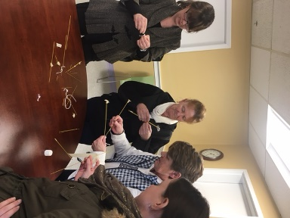

Each team was given a secret package that included, tape, scissors, string, 8 pieces of dry spaghetti and of course- a Marshmallow! Teams had 18 minutes to create the highest structure they could only using the objects mentioned. The two highest structures measured 7 and 10 inches. The exercise was to create teambuilding, communication and to think out side the box….
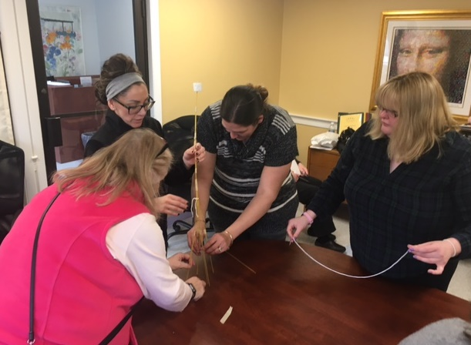 A study showed that among those who created the tallest structures consistently above everyone else was: Kindergarteners!
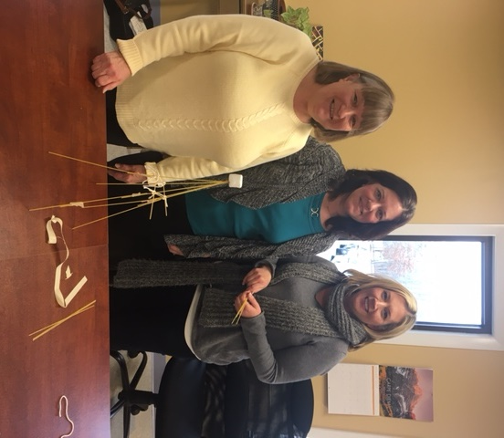
If you would like to know more about the Marshmallow challenge, please visit http://www.tomwujec.com/design-projects/marshmallow-challenge/

