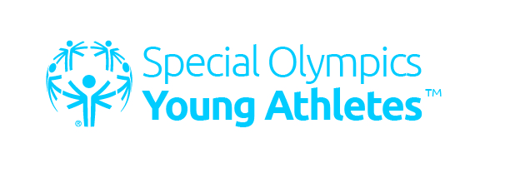

CARDINAL CUSHING CENTERS SPECIAL OLYMPICS

YOUNG ATHLETES PROGRAM

WINTER SESSION ANNOUNCED!

**Who:** Children, ages 2- 7 with intellectual disabilities.

**What:** A FREE, inclusive, unique sports & play program facilitated by trained volunteers, focusing on fun activities important to mental & physical growth. This is an early introduction to sports & the world of Special Olympics.

**Where:** Cardinal Cushing Centers – 405 Washington St., Hanover, MA

**When:** 8 week WINTER session: January 14 – March 11, 2017

SATURDAYS: 10-11:00am

(No program January 28)

**Helpful Resources:** [www.specialolympicsma.org/youngathletes.org](http://www.specialolympicsma.org/youngathletes.org)

Please submit registration form to Program Director Tom McElman at [tmcelman@cushingcenters.org](mailto:tmcelman@cushingcenters.org)

Registration or program questions? Please call Tom at 781-829-1295 or Special Olympics MA Director of Community Development Megan Hoffman at [Megan.Hoffman@SpecialOlympicsMa.org](mailto:Megan.Hoffman@SpecialOlympicsMa.org) or at 508-485-0896 ext. 225

**To Register:**

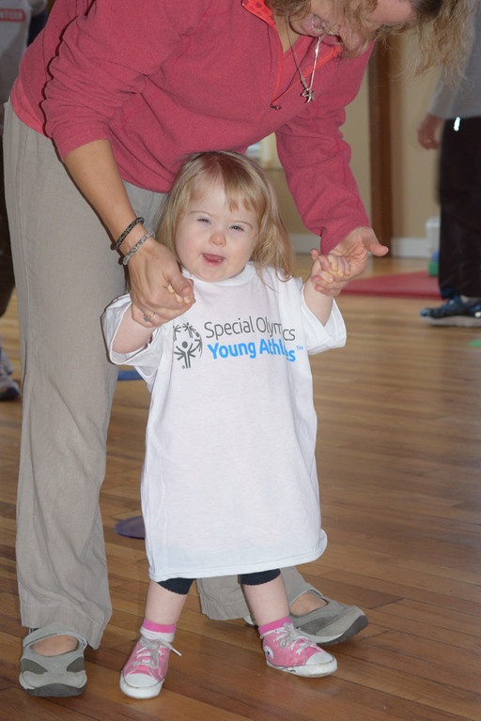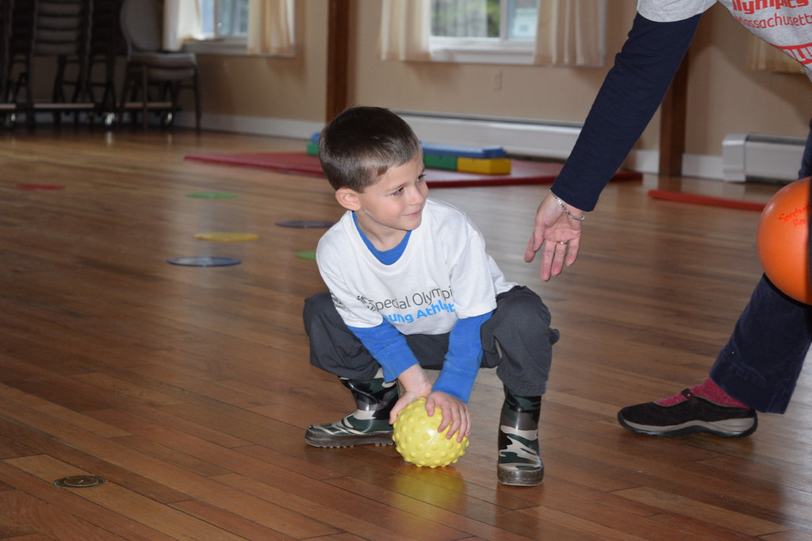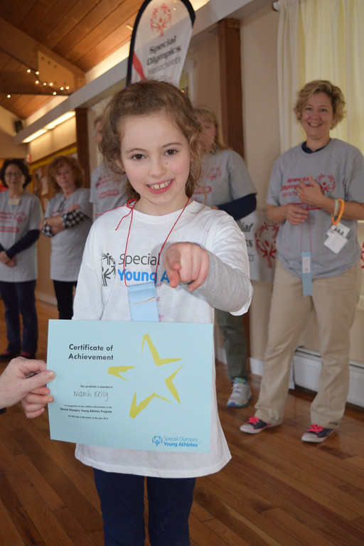

**Young Athletes Registration Form Program Name:**

Special Olympics Massachusetts

512 Forest Street Marlborough, MA 01752

Phone: 508-485-0986 Fax: 508-481-0786

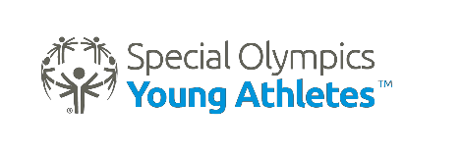

**Athlete’s Name: _ Parent/Guardian Name: What is your relationship to the Athlete you are registering:**

❒ Parent/Guardian  Sibling  Other family member  OTHER (please specify):

**Address: City: State: Zip Code:_**

**Home Phone:_ Cell Phone: Email:**

**Birthday:** Month_ _Day Year

**Gender:** ☐ Male ☐ Female

**Emergency Contact Name: Phone Number: _ Athlete T-Shirt Size:** ☐ Child Small ☐ Child Medium ☐ Child Large ☐ Adult Small ☐ Adult Medium

**Basic Health Information:**

Heart Problems: ☐ Yes ☐ No Blind: ☐ Yes ☐ No Diabetic: ☐ Yes ☐ No Deaf: ☐ Yes ☐ No Epileptic/Seizure:☐ Yes ☐ No Hepatitis: ☐ Yes ☐ No Down Syndrome: ☐ Yes ☐ No

Other:

Allergies:

**Ethnicity**: ☐ White ☐ Black/African American ☐ Asian ☐ Hispanic/Latino ☐ Other:

**Young Athlete is being registered as a:** ☐ Traditional Young Athlete (with Intellectual Disability)

☐ Unified Partner (without Intellectual Disability)

**Young Athletes Release Form**

I am the parent/guardian of the minor participant, on whose behalf I have submitted the attached application for participation in Special Olympics. I further represent and warrant that to the best of my knowledge and belief, the participant is physically and mentally able to participate in Special Olympics.

In permitting the participant to participate, I am specifically granting my permission, forever, to Special Olympics to use the participant’s likeness, name, voice and words in television, radio, film, newspapers, magazines and other media, internet and in any form, for the purpose of publicizing, promoting or communicating the purposes and activities of Special Olympics and/or applying for funds to

support those purposes and activities. I also understand that group data collected from the Young Athletes Pilot Program will be used to plan, evaluate, and improve the program.

If a medical emergency should arise during the participant’s participation in any Special Olympics activities, at a time when I am not personally present so as to be consulted regarding the participant’s care, I hereby authorize Special Olympics, on my behalf, to take whatever measures are necessary to ensure that the participant is provided with any emergency medical treatment, including hospitalization, which Special Olympics deems advisable in order to protect the participant’s health and well -being. **(IF YOU HAVE RELIGIOUS OBJECTIONS TO RECEIVING SUCH MEDICAL TREATMENT, PLEASE CONTACT SPECIAL OLYMPICS MASSACHUSSETTS)**

I am the parent (guardian) of the participant named in this application. I have read and fully understand the provisions of the above release, and have explained these provisions to the participant. Through my signature on this release form, I am agreeing to the above provisions on my own behalf and on the behalf of the participant named above. I hereby give my permission for the participant named above to participate in Special Olympics games, recreation programs, and physical activity programs.

Signature of Parent/Guardian Print Name Date